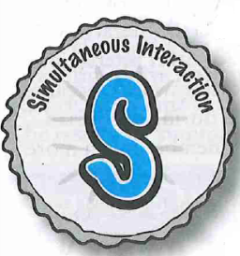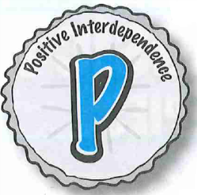

**S – Simultaneous Interaction**

The amount of participation per students and our efficiency in teaching and managing the classroom are increased enormously when we use simultaneous rather than sequential sturctures.

**E – Equal Participation**

Students who otherwise would not participate or who would participate vary little become engaged when we equalise participation.

**I – Individual Accountability**

Individual Accountability dramatically increases student’s participation and motivation to achieve.

**P – Positive Interdependence**

Positive Interdependence creates mutual support among students.

**P.I.E.S – The Four Basic Principles of Cooperative Learning**

(See chapter 5 of Kagan Coopartive Learning course book)

At Richardson Primary School we are committed to improving student achievement through embedding cooperative learning in every classroom.

**What is Cooperative Learning?**

“Cooperative learning is a social process grounded by structured group work, and is concerned with promoting both social and academic outcomes; that is, students learn new social skills and how to work together in order to achieve academic goals. These goals are realised through the  
imposition of structure and control by the teacher. The teacher holds students   
accountable for learning, collectively. In doing so, the teacher acts like a manager   
or director who uses instructional strategies to engender social skills, positive   
interdependence, cooperation, and accountability” ***(Brody, 1995)***.

All classes are equipped with Kagan Cooperative Learning resources to assist  
 with the implementation of cooperative learning. Essential information is outlined   
in the cooperative learning book.

**COOPERATIVE LEARNING AT RICHARDSON PRIMARY SCHOOL**

**Teams**

“Teams promote strong bonds between students, facilitate interaction over curriculum and improve learning.” (See chapter 7 of Kagan Cooperative Learning course book)

At Richardson teams of 2 are used in preschool and through the first 6 months of Kindergarten before moving into teams of 4.

|  |  |  |
| --- | --- | --- |
| **Team type** | **Positive +** | **Negative -** |
| **Heterogenous**  *Mixed ability, sex, race teams*  *Used as home teams. Changed every 5 -6 weeks* | * Balanced * Maximum cross race, cross sex * Maximises tutoring * Management easier for equal ability level teams * High achiever on each team | * Requires teacher prep time * Requires ranking and labelling students * Limited contact between the high achievers * Limited leadership opportunities for achievers |
| **Random**  *Randomly formed teams*  *formed as needed* | * Fair * Side-steps labels and ranking * No prior student knowledge necessary * Classbuilding and networking opportunities * Quick and easy * Novelty, variety, fun | * Could form “winner” and “loser” teams * Diversity not ensured * Teams with friends, potential for off-task behaviour * Teams with enemies and conflicts |
| **Homogeneous**  *Students select own teams*  *formed as needed* | * Leadership opportunities for low achievers * Interaction opportunities for high achievers * Opportunities for some high achievers to experience being a team mate, not a leader * High self esteem * Interest teams promote inquisitiveness | * Too- similar groups lack input in Zone of proximal development * Negative stereotypes * Poor self-esteem for low groups * Lack of equality * Difficult to manage class of teams at different ability levels |
| **Student-Selected**  *Teams with shared trait (ability, interest, language)*  *formed as needed* | * Novelty, variety, fun * Familiarity * Easy decision making and consensus | * Not balanced * High potential for off task behaviour |

**Classbuilding**

Classbuilding “provides greater student empowerment and ownership and result in a feeling that this is “our class”” The two primary approaches to Classbuilding are Classbuilding Activities and Class Restructuring. (See chapter 9 of Kagan Cooperative Learning course book)

At Richardson Primary School we ensure every class does a Classbuilding Activity at least once a week for fun.

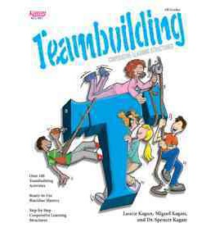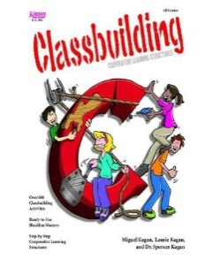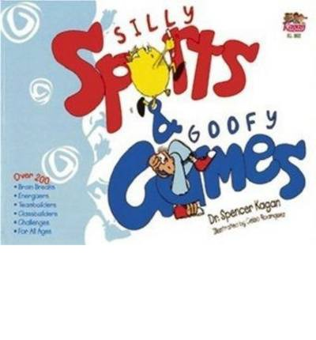

***The five aims of Teambuilding are;***

1. Getting Aquainted – getting to know teammates  
2. Class Identity Building – forming a team identity  
3. Mutual Support – feeling supported by teammates  
4. Valuing Differences – Clarifying and respecting differing values  
5. Developing Synergy – building on teammates’ contributions

**Teambuilding**

“Teambuilding is the process by which different students come to know, trust and respect their teammates” (See chapter 10 Kagan Cooperative Learning course book)

At Richardson Primary School we ensure that Teambuilding happens at least twice a week and should be fun, non-academic and easy for all.

***Purpose for Class Restructuring;***

1. Class Meetings  
2. Setting Class Goals  
3. Setting Positive Class Tone – ***Silly Sports & Goofy Games***  
4. Enhancing the Class Climate  
5. Class Empowerment  
6. Student Input  
7. Student Ownership of the Classroom  
8. Student Choice  
9. Student Evaluations

***The five aims of Classbuilding Activities are;***

1. Getting Acquainted – getting to know classmates  
2. Class Identity Building – forming a class identity  
3. Mutual Support – feeling supported by classmates  
4. Valuing Differences – Clarifying and respecting differing values  
5. Developing Synergy – building on classmates’ contributions

**Structures**

“A structure is the way a teacher organises the interaction in the classroom at any moment.” Structures organise classroom instruction, are content free and implements the basic principles of Cooperative learning (PIES) (See chapter 6 Kagan Cooperative Learning course book). Many structures can be used to develop and enhance social skills in students.

Kagan Trainer Rob Jutras in consultation with Dr Spencer Kagan identified “The Essential 5” Cooperative learning structures as a starting point for any Cooperative learning classroom.

1. RallyRobin  
2. Timed Pair Share  
3. RoundRobin  
4. RallyCoach  
5. Stand Up, Hand Up Pair Up

Many structures have social skills built into their steps. At Richardson we regularly use structures that give students opportunities to practice social skills in a natural way. A chart identifying the specific social skills used in each structure can be found in the Social Skills chapter (chapter 11) of the Kagan Cooperative Learning course book.